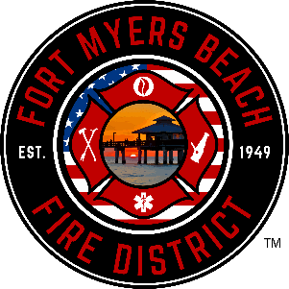

**Board Of**

**Fire Commissioners**

John Bennett Chair

Larry Wood Vice-Chair

Jim Knickle

Secretary/Treasurer

Ronald P. Fleming

Fire Commissioner

Jacki Liszak

Fire Commissioner

**Fire Chief**

Scott Wirth

**Fort Myers Beach Fire Control District**

**BOARD OF FIRE COMMISSIONERS**

**Final budget hearing**

**AGENDA**

**September 27, 2023 5:15pm**

2000 Estero Blvd, Lobby Level, Fort Myers Beach, FL 33931

1. Hearing Called to Order
2. Pledge of Allegiance
3. Adoption of Agenda [Discussion/Approval]
4. Restate Agenda Items [Information]
5. Consent Agenda [Approval]

*Items listed are considered routine and action will be taken by one motion; if a Commissioner desires discussion, the specific item will be removed during the Adoption of the Agenda and considered separately.*

* 1. Approval of Meeting Minutes from September 13, 2023

1. Highlights of Proposed Budget & Millage Rate [Information]
2. Adoption of Millage Rate – Resolution 2023-03 [Introduction/Public Input/Discussion/Adoption]
3. Adoption of Budget – Resolution 2023-04 [Introduction/Public Input/Discussion/Adoption]
4. Fire Chief Remarks [Information/Discussion]
5. Commissioners Remarks [Information]
6. Adjournment